June 2025

Dear Future 3K Families,

Welcome to 3K!

In order to help you prepare for an exciting year of learning, here are some supplies you will need for their 3K school year.

**Bring these items to school with you on the first day.** ​Kindly label your supplies in advance.

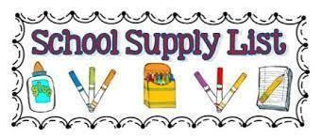

| * A change of clothes labeled with student first and last name placed in a ziplock bag. Long pants and long sleeve shirt. (Name on the bag) * One small crib-size fitted sheet. * One very small pillow or small stuffed animal/character. (This is optional) * One red plastic folder for Homework * One yellow plastic folder for classwork * One pack of pre-sharpened #2 **Ticonderoga** pencils * One pack of pre-sharpened **Ticonderoga** “fat” pencils * 2 packages of Expo dry erase markers (Black) * 4 glue sticks (small) | * 1 package of quart-sized Ziploc Baggies * 1 package of gallon-sized Ziploc Baggies * 2 rolls of paper towels * 2 boxes of Kleenex tissues (I will ask for additional throughout the year as needed) * 2 packages of disinfecting wipes (Lysol preferred) * 4 packs of baby wipes * 2 bottles of hand sanitizer to share with class |
| --- | --- |