June 2025

Dear Future Third Grade Families,

Welcome to Third Grade!

In order to help you prepare for an exciting year of learning, here are some supplies you will need for their 3rd grade school year.

**Bring these items to school with you on the first day.** ​Kindly label your supplies in advance.

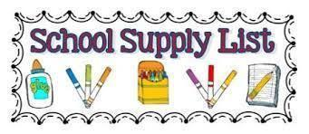

| * 5 wide-ruled marble notebooks, labeled with first and last name. * 2 Boxes 72 count pre-sharpened #2 **Ticonderoga** pencils   **(NO MECHANICAL PENCILS)**   * 1 **large** **soft** pencil case with zipper for school supplies. **No hard plastic boxes.** * 1 pack Crayola colored pencils (**NO MARKERS)** * 1 box **green** pens * 1 box **red**  pens * 4 **HARD PLASTIC** folders (1 of each color, green, red, purple, orange, yellow, blue) * 1 pack of thin Expo dry erase markers * 1 pack of thick Expo dry erase markers * 2 large glue sticks * 1 pair of scissors * 1 plastic 12 inch ruler with inches and centimeters * Activity/coloring book for rainy day recess | * 2 reams of white printing paper * Earbuds or headphones in a ziploc with student names (for iPad/laptop use, stays in school) * 3 containers disinfecting wipes * 3 rolls of paper towels * 3 boxes of tissues * 1 box quart size ZipLoc bags   (boys only)   * 1 box gallon size ZipLoc bags   (girls only)  ***\*Having a reusable water bottle will be helpful throughout the year. Please label with your child’s name. Make sure it is a snap top and not a straw top- to prevent spills.***  ***Be on the lookout for the Staples and Walmart pre-season sales to get many of these items at a steep discount!*** |
| --- | --- |