June 2025

Dear Future Fifth Grade Families,

Welcome to Fifth Grade! We're thrilled for an exciting year. To ensure your child is ready to learn from day one, please bring these essential supplies on the first day of school. Don't forget to label each item with your child's name!

Thank you!!

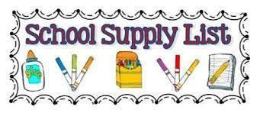

| * **1 set of inexpensive earbuds or headphones to keep in class** * 5 wide ruled marble notebooks, labeled with first and last name. (ELA, Math, Music, Art, Science) * 5 two-pocket folders (labeled with name; preferably plastic, 1 red, 1 blue, 1 green, 1 yellow, 1 choice) * 4 boxes of sharpened #2 pencils * A box of eraser caps or pack of large pink erasers * 3 rolls of paper towels * 5 boxes of tissues (we will ask for additional throughout the year as needed) * 2 packages of disinfecting wipes (Lysol preferred) * 1 bottle of hand sanitizer to share with class. | * 1 pack of glue sticks * 1 box of crayons * 1 ream of white copy paper * **Leak-proof reusable water bottle to eliminate the need to frequently visit the water fountain.**  ***Make sure it is a snap top and not a straw top- to prevent spills.*** * **Pencil case–In an effort to conserve space, please do not purchase large pencil cases**   **\*Please label your child’s clothing\***  (Coats and sweatshirts) |
| --- | --- |