June 2025

Dear Future Pre-K Grade Families,

Welcome to PreKindergarten!

In order to help you prepare for an exciting year of learning, here are some supplies you will need for their Pre-K school year.

**Bring these items to school with you on the first day.** ​Kindly label your supply bags in advance.

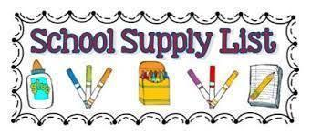

| * A change of clothes labeled with student first and last name placed in a ziplock bag. Long pants and long sleeve shirt. (Name on the bag) * One small crib-size fitted sheet. * One very small pillow or small stuffed animal/character. (This is optional) * One red plastic folder for Homework * One yellow plastic folder for classwork * One pack of pre-sharpened #2 **Ticonderoga** pencils * 2 packages of Expo dry erase markers (Black) * 4 glue sticks (small) | * 1 package of quart-sized Ziploc Baggies * 1 package of gallon-sized Ziploc Baggies * 2 rolls of paper towels * 2 boxes of Kleenex tissues (I will ask for additional throughout the year as needed) * 2 packages of disinfecting wipes (Lysol preferred) * 2 packs of baby wipes * 2 bottles of hand sanitizer to share with class |
| --- | --- |