June 2025

Dear Future Kindergarten Grade Families,

Welcome to Kindergarten!

In order to help you prepare for an exciting year of learning, here are some supplies you will need for their Kindergarten school year.

**Bring these items to school with you by Friday, September 5th.** ​Kindly label all bags.

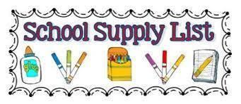

| * 3 plastic folders (no side pockets- bottom pockets only) * 3 boxes of pre-sharpened #2 **Ticonderoga** pencils * 2 boxes of **Crayola** crayons (24 count) * 1 box of **Crayola** colored pencils (12 count in each box) * 1 pack of multi-colored construction paper * 3 Jumbo **Elmer’s** glue sticks * 1 bottle of **Elmer’s** glue * 1 pair of blunt edge scissors * 2 packages of **thin** **black** Expo dry erase markers * 2 packages of **thick** **black** Expo dry erase markers * 2 rolls of paper towels (we will ask for additional throughout the year as needed) * 2 boxes of Kleenex tissues (we will ask for additional throughout the year as needed) * 3 containers of baby wipes | * 2 bottles of antibacterial soap * 1 bottle of hand sanitizer * 1 quart -size box of Ziploc bags * 1 gallon-size box of Ziploc bags * 2 packages of disinfecting wipes (Lysol preferred) * **1 set of inexpensive headphones with a jack** to keep in class   ***\*Having a reusable water bottle will be helpful throughout the year to eliminate the need to frequently visit the water fountain. The bottle should have a snap top not a straw top to prevent spills***  ***\*1 complete change of clothing in a labeled bag (please include socks, underwear, pants, and a shirt)*** |
| --- | --- |